Project Development Phase
Model Performance Test

Date | 19 February 2026
Team ID | LTVIP2026TMIDS66107
Project Name | Hematovision: Advanced Blood Cell Classification Using Transfer Learning
Maximum Marks | 4 marks

Model Performance Testing:
Project team shall fill the following information in model performance testing template.
S.No. | Parameter | Values | Screenshot
 | Model Summary | Model: MobileNetV2 (Transfer Learning) with an added Dense layer. Total parameters: 2,586,948. Trainable parameters: 328,964. Non-trainable parameters: 2,257,984. | 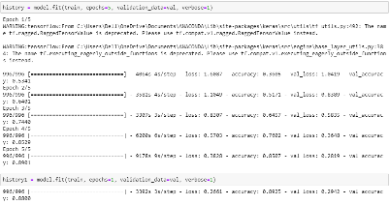
 | Accuracy | Training Accuracy – 0.89.3 (from Epoch 12/15)  Validation Accuracy - 0.81462 (from Epoch 12/15) | 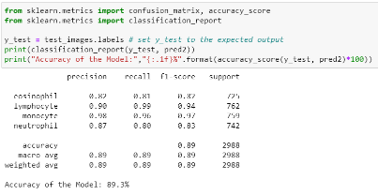
3. | Fine Tunning Result( if Done) | Validation Accuracy -  Fine-tuning of the pre-trained MobileNetV2 base model was not performed. Only the newly added dense layer was trained. | 

